**. Write a C program to implement Queue operations such as ENQUEUE, DEQUEUE and**

**Display**

**INPUT:**

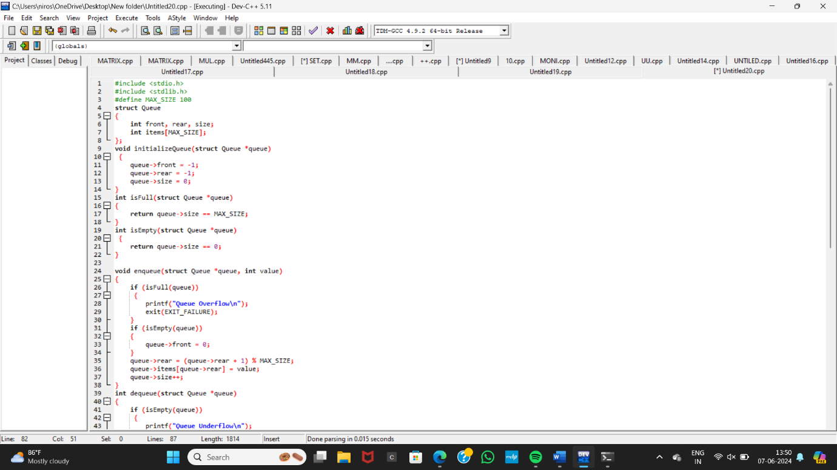

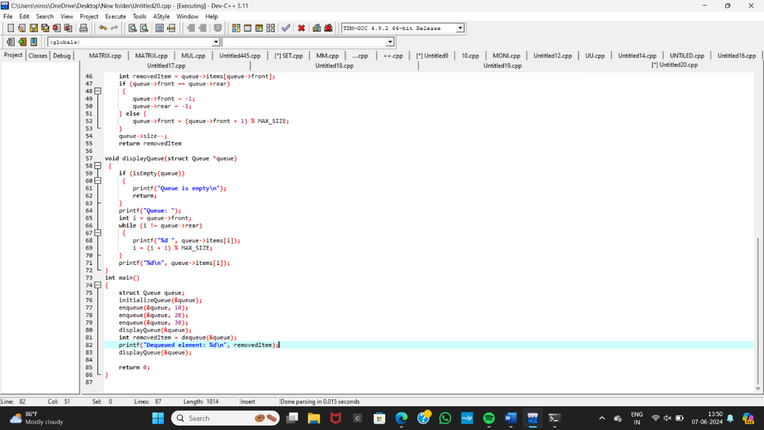

**OUTPUT:**

